Submitted by Anne Iehl - Secretary

Alta Library Minutes from July 26, 2023 Meeting below:

Call to Order by Tirzah Price at 518 p.m.
Present: Director: Tirzah Price and interim director Gigi Nelson Board: Anne Iehl, Colleen Schwanz, Willa Casstevens, Colleen Carlson-Konop and Bruce Hinkeldey. Absent: Anna Garcia

Approve July Special Meeting Agenda - No changes. Motion to approve by Colleen C-K, 2nd by Willa. Approved

Citizen Input – none

Library Director Hiring Discussion –
Discussed interview of Lisa Agunda and terms of hiring. Tirzah drafted a letter to send Lisa with terms of employment for her to consider. Bruce agreed to call and discuss with her.

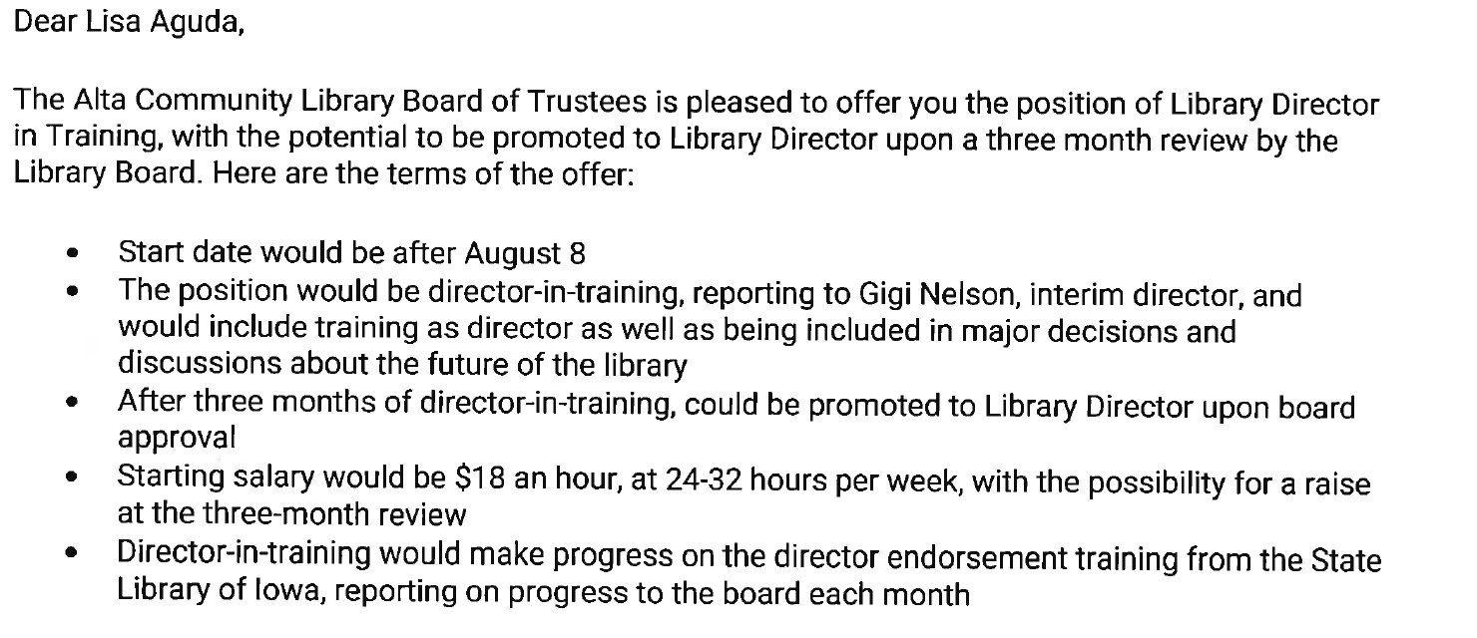

Motion to move forward with hiring Lisa Agunda with above terms by Colleen S, 2nd by Willa. Approved.

Next Meeting: August 10, 2023 @ 5:15pm

Meeting Adjourned @ 6:08 pm

